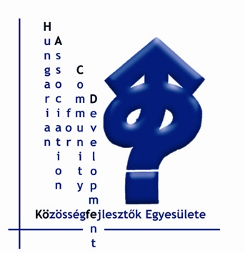 | Közösségfejlesztők Egyesülete  Association for Community Development  Association du Développement Communautaire  1011 Budapest, Corvin tér 8.  1251 Budapest, Pf. 42  E-mail: kofe@kkapcsolat.hu  Telefon: (36-1) 201 57 28, Fax: (36-1) 225-60-13, www.kka.hu

European Dialogue
CEBSD-CEE CN

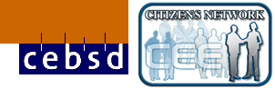

Programme for Joint Meeting on 9th and 10th May at Kunbábony

Thursday, 8th May
Arrival day. We kindly ask the participants to arrive before 13.00 and please register at HACD’s office: 1011 Budapest, Corvin tér 8. (registration from 11.00).
Lunch from 12.00 in the registration venue
14.00: Opening Ceremony and Press Conference on the Europe Boat
appr. 15:30 Departure to Kunbábony (journey takes 1,5 hour)
Accommodation, dinner, social evening

Friday, 9th May

9.00-9.30 Welcome and network circle
9.30-9.50 Ilona Vercseg: opening
9.50-10.20 Panel
Hans Andersson CEBSD, Chuck Hirt CEE CN and Ilona Vercseg HACD Central-Eastern and Western Europe in a deeper context
10.20-11.00 Discussion
11.00-11.30 Break
11.30-13.00 Introduction of the two networks:
This is done in the format of interviews with 3-4 people from each network, than we let space for questions from audience.
13.00 Lunch and informal networking
14.30-14.50 Kirsten Paarby: Introduction of the afteernoon’s topics and working methodology (Café Dialogue)
- Localisation - Globalisation? - CEECN host
- Dialogue between citizens groups and local authorities (legal framework and practices) - CEECN host
- Local elections and local representation - CEECN host
- Including the excluded - CEBSD host
- Intercultural dialogue - CEBSD host
- CD as an approach to citizens’ participation - CEBSD host
- Europe: Differences and similarities in European Civil Society: - HACD host, Máé Varga

Aim: giving and getting information, sharing, outline the common interests
      - Beak and stretch legs
16.35-17.20 Kirsten Paarby: Express the main focuses of the Café Dialogue (Bull’s eye method)
  - In-depth discussion and preparation of presentation (groupwork)
19.00 Dinner

Saturday, 10th May

9.00 Welcome to the new day: Máté Varga
10:00 Presentations on Café Dialogue (max 10 mins each) and reflections. Café Dialogue closes.
      - Break
11.10-11.40 Anna Karailieva, Margo Gorman: Future Timeline presentation
Aim: to build on, to enrich and enhance existing actions and proposed events.
To set up a timeline of these events on flipcharts wall, create dialogue what else can we do together and when (presentation and groupwork)
11.40-13.00 Groupwork
(4/5 allocated groups will make suggestions about future steps. What can we combine, what are our possibilities based on all the ideas? Discussion and dialogue that we have had).
13.00- 13.30 Feedback from groups and this feedback will be taken to the two networks.
Speed Dialogue – some points for evaluation.

Close

Afternoon: CEBSD Board Meeting, CEE CN RT Meeting, than common evaluation
Dinner and evening programme

Sunday, 11th May
Departures

Our supporters

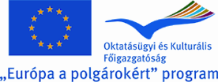 | 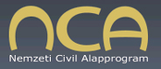
Co-financed by the European Union within the programme "Europe for Citizens" 2007 – 2013. | National Civic Fund

